Canterbury Street Pastors Annual General Meeting

2016 Report

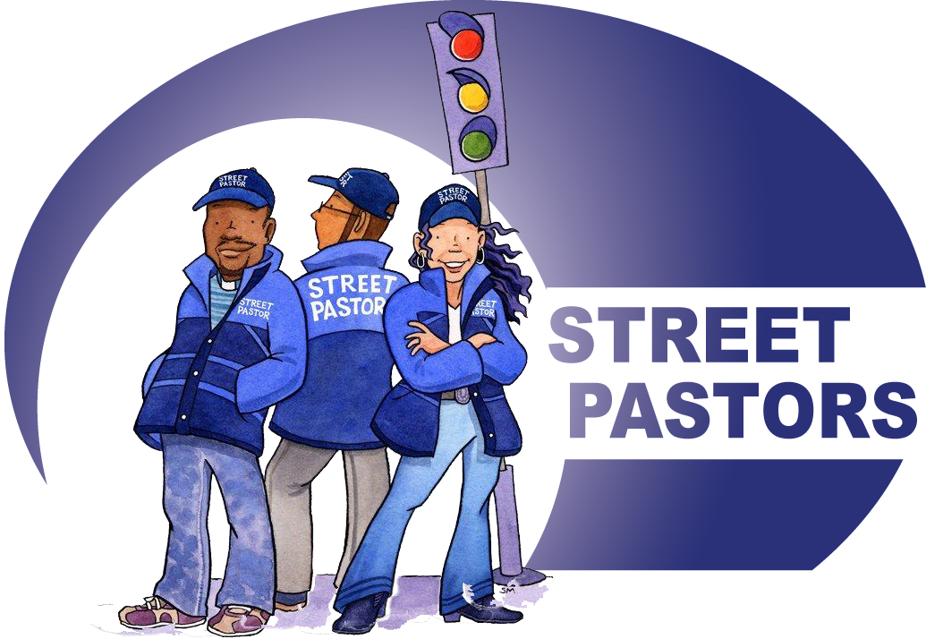

**Contents:**

Meet the Team

Report from the Chair

Report from the Prayer Coordinator

Report from Coordinator

Website and Social Media

Meet The Team

Below is our current list of 31 Street Pastors and together with our Prayer Pastors and Management Group this represents the participation of 18 different church fellowships. (Those marked with + are currently on sabbatical)

The Prayer Pastor list is just a small representation of those who come and pray. We hope to encourage more folk to join us in this important ministry of prayer and hospitality.

Those on the list marked with + are currently unavailable to patrol at present.

As well as the addition of new members to our team, we have seen others leave due to changes in personal circumstance. So at this point I would like to express our thanks to: Chris Pestell, Maggie Pearson, Susanna Taylor, James Agebon and Rena Yiaptou

|  |  |  |
| --- | --- | --- |
| **Street Pastors** | **Management Group** | **Prayer Pastors** |
| Lorna Bedford –URC | David Clegg (Chair) – Ash CofE | Geoff Farnham – Vineyard |
| John Morrison – CC CofE | Simon Redman (Vice Chair) – SMB | Andrew Pantling – All Saints |
| Geoff Farnham – Vineyard | William Pettit (Sec) – Cathedral | Liz Jenkins – Barton |
| Liz Jenkins – Barton + | Will Howe (Treas) – Methodist | Alice Corfield – Barton |
| Gemma Traquair – All Saints | Geoff Farnham (Pray Co) – City | Richard Farrant – Boiler Room |
| Mark Jennings – City | Julian Coode – Baptist | Lyndall Bywater – Boiler Room |
| Paul Chandler – Beacon HB | Sally Waters – All Saints | David Clegg – Ash CofE |
| Doreen Laven – St Martins CofE | Margaret Northey – St Mildred’s CofE | Richard Nicholas - URC |
| Liz Madge – Barton + | Alice Corfield – Barton | Rosemary Patton - URC |
| Margaret Northey – St Mildred’s | Gemma Traquair – All Saints | Harry McDonald - SMB |
| Mark Callanan – Canopy |  | Alison McDonald - SMB |
| Julia Bartlett – Barton |  | Mark Jennings - City |
| Rosemary Patton – URC |  | Lizzie Jennings - City |
| Avril Leyton – |  | Kay Chandler – Beacon HB |
| Pat Banks – Canopy |  |  |
| Bug Price – Barton |  |  |
| Maureen Smith – SMB |  |  |
| Terry Smith – SMB |  |  |
| Michelle Torok – CofE |  |  |
| Sally Barnes – City |  |  |
| Judith Daley – New Life |  |  |
| Niall Greathead – City |  |  |
| Julie Donlan - Barton |  |  |
| Micael Christoffer – Fr Brother |  |  |
| Andrew Johnston – Ash CofE |  |  |
| Filippo Marozelli - SMB |  |  |
| Michael Mount – Sal. Army |  |  |
| Holly Adams – All Saints |  |  |
| Mark Ball – Rev. City Parish |  |  |
| Melissa Devine – St Dunstans |  |  |
| Jason Hanford – SMB (Trainee) |  |  |

We express grateful thanks to God for the work of this team for their dedication and commitment to this ministry.

Chairman’s Report – David Clegg

It has been a privilege to serve as chair of Canterbury Street Pastors (CSP) this last year. It is great to be involved with people from different churches who want to serve God.

This year we celebrated CSP’s 5th birthday and we also became a registered charity. This will enable us to access new funding opportunities and enhance our transparency. Lorna has worked hard to build up the whole team, promote us effectively throughout Canterbury, build partnerships with other Street Pastor groups in East Kent and win new funding.

You will see key information, reports and stats about CSP on the website and I would encourage you to have a good look when you get the chance. (Thanks to Gemma Traquair for ongoing development)

At the commissioning service at St Andrew’s URC this March Les Isaac, mentioned a number of times that Street Pastors was all about Jesus. If He is in charge then we can’t go far wrong. We just need to listen to His guidance and follow it.

Street Pastors are there to ‘Care, Listen & Help.’ This is what a team of willing volunteers do in Canterbury week in and week out, no matter what the weather, supported by a team of prayers. In terms of prayer, William Temple once said, “When I pray coincidences happen, and when I don’t pray, they don’t.”

Thank You’s

* We thank God for all His provision.
* We want to thank St Peter’s church for hosting the AGM this evening.
* We want to thank the teams of individuals who are the ‘boots on the ground’ doing the stuff on Saturday and sometimes Friday nights.
* We want to thank the members of the management committee for their support, dedication and hard work. (If you are interested in becoming involved then please speak to one of us.)
* We want to thank Lorna: I don’t know where to start, but excellent is not a sufficient word for someone who has done so much to promote CSP so well.
* We want to thank all the churches and organisations and individuals who have supported the work of CSP in whatever way.
* We want to thank all the fruitful partnerships that we have: The police, the ambulance services, the pubs, clubs, Canterbury City Council, etc, etc.

Prayer points for The Future

* Recruit/train new Street Pastors from a diverse variety of churches
* Recruit more prayers to provide prayer cover in the prayer room and at home
* Continue to promote the ministry across the community and develop our relationships with partners throughout the community

Prayer Coordinator’s Report – Geoff Farnham

Providing prayer cover every time the Street Pastors are out on patrol has not been without difficulty this year, and on admittedly rare occasions this has been down to a single prayer. We are grateful for such dedication.

In the past we had several individuals who frequently inhabited the prayer room and they fortuitously plugged gaps when they occurred. Unfortunately for various understandable reasons these much appreciated folk have not been able to continue with us and this has exposed the weaknesses in our prayer support when sickness or the vagaries of life have meant assigned prayers have been unable to attend their allotted nights. Fortunately on some occasions the Street Pastors team has been robust enough for one of the team to help the prayer effort for a period and this is much appreciated.

Difficulties and limitations notwithstanding our prayers on Saturday and occasionally other nights continue to support the efforts of our Street Pastors. Answers to prayer are tangible and often encouraging, fraught situations are changed and replaced with a noticeable peace, difficulties are resolved and answers found to intractable situations. It is not uncommon for patrols to occur that are without incident and drawn to a close early after a final sweep of the city proves all is at pace.

The prayer team now have the advantage of a City Watch radio in the prayer room that enables them to pray into situations occurring in the city which may not specifically involve the Street Pastors. On one notable occasion soon after having the radio facility the prayer team’s attention was drawn to a situation in Rose Lane which could be observed from St Andrews prayer room window; the problem was solved within less than five minutes of our prayers rising heavenwards.

Prayers have now been made on almost every Saturday night for our city for over five years, it cannot be a coincidence that we recently had one of our most fulfilled patrols with many encounters, faith chats and prayer requests occurring throughout the patrol.

As the prayer coordinator my heartfelt thanks are extended to all who support the Street Pastors prayer initiative. Perhaps our ineffable God will infuse His people with a new passion for prayer and our prayer support be much increased as a result. Our current often-limited numbers achieve some good results, James 5:16b says, "*The effective prayer of a righteous man can accomplish much".* Just think what could be achieved if many righteous men and women gather to pray on Saturday nights for our city.

To God be the Glory!

Coordinator’s Report 2016 – Lorna Bedford

I would like to start my report with my personal thanks to the Street Pastor Team, Prayer Team and Management Group for their support, encouragement and commitment to the ministry here in Canterbury.

As a team we can witness to the fact that God is at work in our City. Week by week we often see the atmosphere of the City change as a direct result of prayer, we find solutions to what might seem a difficult situations and we are guided by God’s Holy Spirit as we serve our city.

Thank you all for the part you play in this ministry but especially to our prayer teams who week by week provide prayer, encouragement and hospitality for our team.

I would also like to thank Street Pastors from Herne Bay who regularly support our team here in Canterbury: Darren Hibbert, Adrian Cooke and Maureen Brunt.

We continue to look for opportunities to promote our ministry across the churches, schools and in our wider community. This has meant that I have found myself speaking at WI groups, church fellowships, British Legion and even did an after diner speech for the Barham Bowls Club. Liz Jenkins has developed a great link with Kings School and we were delighted when they nominated us as their chosen charity at Christmas. Doreen Laven is also a regular speaker at various groups.

We also have practical and financial support given to us from other members of the night-time economy like businesses and clubs. This includes financial gifts, and donations of Space Blankets, Rain Ponchos and bottled water. This year Canterbury was successful in retaining it’s Purple Flag Status and in this process the work of Street Pastors was commended. This process was driven by the Canterbury ‘BID’ and they have offered ongoing funding for four years. We successfully obtained a “Council Small Grant” of £500 which is to be used towards the purchase a Laptop for our ministry.

Commissioning and Celebration 2015

We held the first ever Kent Wide Commissioning Service in Canterbury at St Andrew’s URC on Sunday 20th March.

For the evening we were joined by Rev Les Isaac the CEO of Ascension Trust, Lord Mayor Sally Waters and Ch. Insp. Neil Jerome.

It was fantastic to see the building packed for the Commissioning of over 30 Street Pastors who will serve in the SP areas across Kent. The evening could be summed up in these words from Doreen Laven:

*“The Commissioning service was arranged beautifully - a mixture of spirituality, ceremony and humour. The atmosphere was lovely and Les Isaac’s words to us were absolutely wonderful. I felt renewed and uplifted”*

Training

The ongoing programme of training that is shared by all Street Pastor groups across Kent still continues and is greatly valued by the groups in Kent.

Kent People’s Trust (KPT) and Canterbury Christian Council have both provided grants towards the cost of training and equipping our new Canterbury recruits.

Website and Social 2015 – Gemma Traquair

Facebook likes have increased over the year. Video, press and snippets of our night on the street are the posts with the most engagement.

Total likes as of 1st Jan 16 was 324.

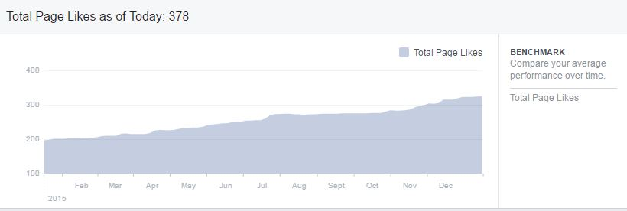

We have made less use of Twitter this year but we still have a good following.

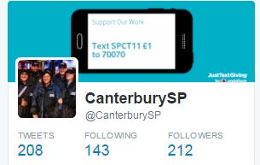

The website continues to be a good place to advertise what we do with increased views during the months we have added news stories, especially when these have been promoted via Facebook.

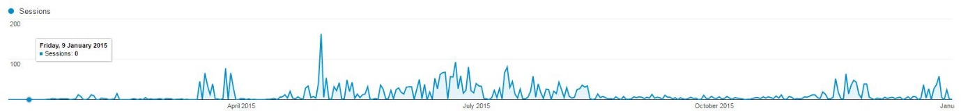

Ways to support and give:

Charity ‘100 Club’

Join our regular giving club and by committing £5.00 a month to support our ongoing ministry. Pick up a leaflet or contact our Coordinator for more information.

Easyfundraising

If you shop on line you can raise money for Street Pastors at no extra cost to yourself by using easyfundraising. Please help support Canterbury Street Pastors in this way: get started now - <http://www.easyfundraising.org.uk/invite/IFHYPO/>

Text Giving

Donations to Street Pastors can now be made via a mobile phone:

To donate via Just Giving text SPCT11 £1 (or any other amount) to 70070

**Report from the Treasurer (24th June 2016)**

At this year’s AGM we present a report showing our new financial year, ending December 2015, together with 2016 figures and a projection to the end of this year. The accounts were recalibrated to line up with the Ascension Trusts method of accounting.

As commented on last year, I believe that Canterbury Street Pastors demonstrates that it is both a necessary initiative, as well as being a viable and efficient organisation. The real (financial) cost of this service in terms of the efforts on the part of our volunteers is not reflected in this statement. We continue to be a relevant part of the narrative that makes Canterbury one of the safest cities for students, although our work actually reaches out to all residents, visitors and the surrounding community.

|  |  |  |  |  |  |  |  |  |  |  |  |  |  |  |  |  |  |  |  |  |  |  |  |  |  |  |  |  |
| --- | --- | --- | --- | --- | --- | --- | --- | --- | --- | --- | --- | --- | --- | --- | --- | --- | --- | --- | --- | --- | --- | --- | --- | --- | --- | --- | --- | --- |
|  | |  |  |  | | --- | --- | --- | | 1 | CASH | 3 | | 2 | BUSINESS | 6 | | 3 | CLUBS & SOCITIES | 10 | | 4 | CHURCH GIVING | 9 | | 5 | CHEQUES | 14 | | 6 | FOUNDATIONS | 19 | | 7 | 100 CLUB | 8 | | 8 | PUBLIC AUTHORITIES | 32 | | 9 | EASY FUNDRAISING | 0.3 | |

Income Streams 2015

During 2015 the year the management team sent out requests for support from the Canterbury Church networks, as well as grant applications and direct approaches to businesses and public authorities. This call returned a reassuring response evidencing our ecumenical diversity and vote of support from the community for all that we do. I have used the Year ending data to compile a chart and include the following notes by way of clarification:

* Public Funding (32%) comprised: KCC, Canterbury City Council, Kent Police, Councillor Northey.
* Foundations (19%) comprised: The Kent Peoples Trust, The Knox and Beerling Foundation.
* Cheques & Cash (17%- Combined Total) comprises of contributions from guest speaking, church offerings, events and coffee mornings, individual gifts.
* Church Giving & 100 club (17 % - Combined total) comprises of individual, Church contributions (City Church, Mary Bredin, St. Martins & St.Pauls, St. Andrews) as well as our regular 100 club gifts.
* Businesses (10%) comprises of contributions from The Cuban and Club Chemistry, Waitrose and ASDA community/green disks schemes.

Notable Changes

There was an increase in training activity and associated expenses. Our operational budget projection for 2015 was set for £10500, which did not take into consideration that 15% level on our receipts that is contributed to The Ascension Trust. In view of this, it seems appropriate to set our operational budget for the year at £12,000. In real terms this means that we need a revenue stream of about £1200 per month. Again, as previously mentioned, when you look at the activities and ‘outreach’ associated with Canterbury Street Pastors, it is realistic to say that no other organisation does what we do, in the way that we do for such a modest financial input.

Performance. In comparing the Mid-Year reference points for 2015 ( £4894.20) with 2016 (£5221.69) we can see that we remain on target and are managing within the frame work of our operational budget.

**BANK DETAILS**

Bank Address: HSBC, 9 Rose Lane, Canterbury, CT1 2JP.

Account Name: Canterbury Street Pastors

Sort Code: 40-16-11

Account Number: 72295547

**SP-AGM-2015 ACCOUNTS**

**SP-AGM-2016+PROJECTION**