Standing Order Mandate
Please pass this form on to Doncaster Street Pastors, using the Street Pastor address at the bottom, who will save a copy for their records. They will then send it on to your bank or building society at the address you give below the Street Pastor address
Full name

Address :

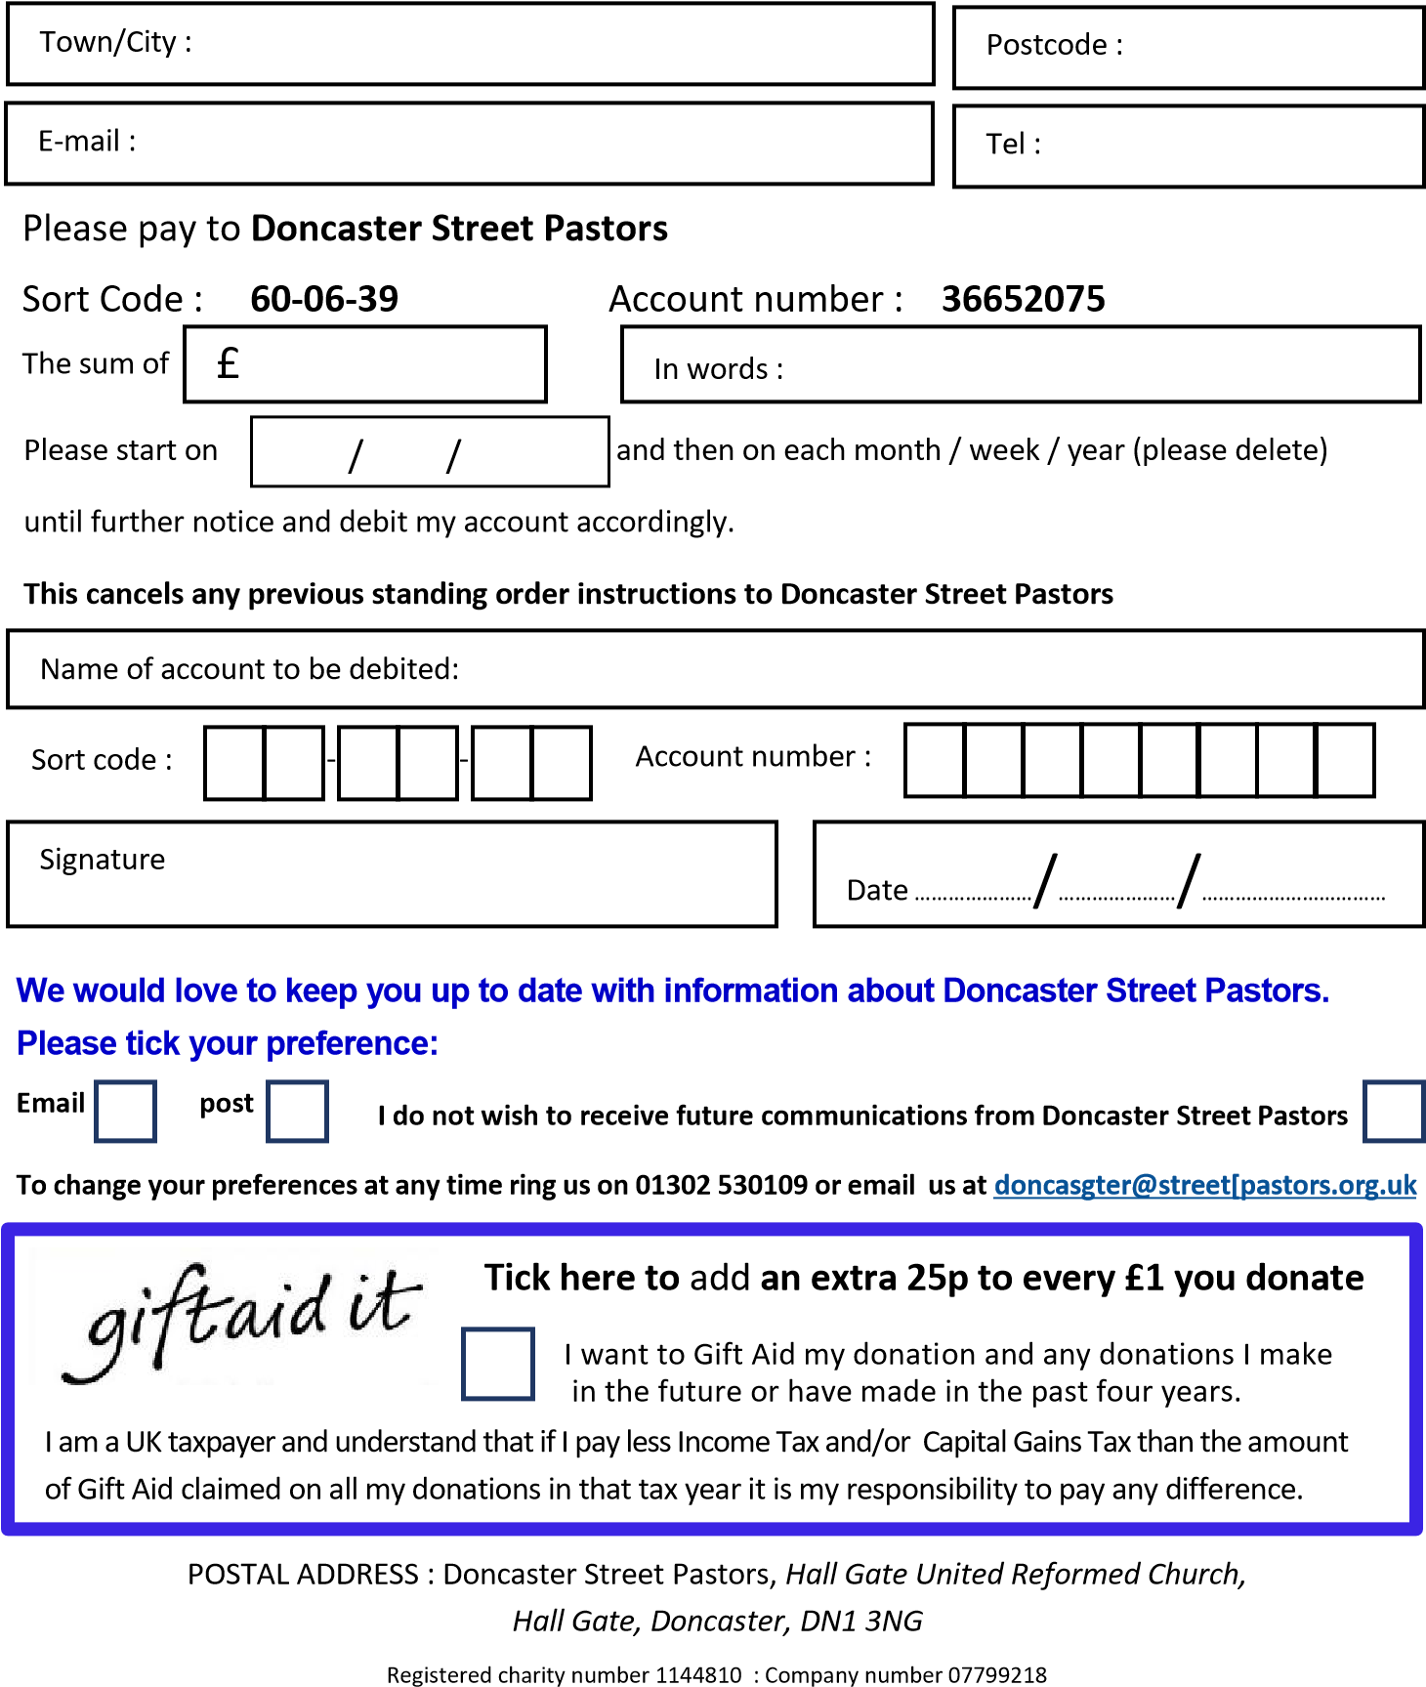

Your bank name and address :

