Prayer newsletter 526 4th and 5th November 2016

STREET PASTORS KINGSTON WIN ‘OUTSTANDING’ AWARD
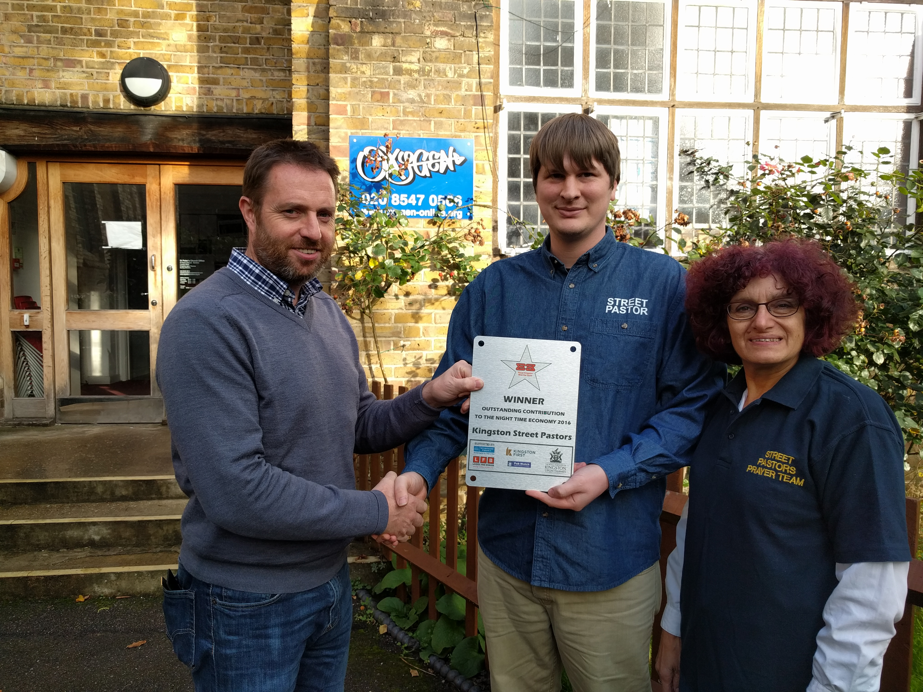
Oxygen Director John Trend congratulates Charlie Bamford and Sue Shaw
This week Street Pastors Kingston received the award for Outstanding Contribution to the Night Time Economy 2016 at a ceremony hosted by Best Bar None. This is a National Award Scheme supported by the Home Office, aimed at promoting responsible management and operation of alcohol licensed premises.
The Award, which was totally unexpected, was presented at Pryzm night club to Sue Shaw with fellow Street Pastors, Luke Randall, Katie Cooper, William Allberry and Sarah Stokes. There was lots of cheering and whooping and a great party atmosphere. The ceremony included awards for best pub, club, bar staff, atmosphere, and front of house people.
The scheme was piloted in Manchester in 2003 and found to improve standards in the Night time economy, reducing alcohol related crime and promoting partnership approaches to resolving problems. It has since been adopted by 75 town and cities across the UK and is being taken up internationally.
Best Bar None has been running in Kingston for ten years, the same period of time as Street Pastors Kingston.
Thank God for the high regard in which Street Pastors Kingston are held
POLISH AND HOMELESS
Friday team: Tracey O’Shea (L); Sue Liptrot; Katie Cooper; Howard Philipps; Prayer Pastors: Dave Pamphilon; Ray Taylor; Visitor: Rory McCann

12.00 At the back of Kingston Churches Action on Homeless (KCAH) and we have just met up with S, a Polish homeless guy, and G, a female heroin addict in her 40s. G has broken fingers and all sorts of problems going on at the moment and is saturated with rain so we are going to get her a sleeping bag. There was another guy with them.

S said rather than give him a sleeping bag could we help his two friends? He took us round the corner and underneath the stairwell were two Polish guys soaked by the rain. One had surgery on his hand yesterday and is all bandaged up. He says that Kingston Hospital just put him out on the street but he still has his name tag on his wrists.
We are going to URC and hopefully there are two sleeping bags down there. Tracey saw a coat with the sleeping bags so will give that to them as well.

1.10 Just leaving the URC laden down with three sleeping bags and a coat and going back to find our two Polish guys in the cabin under the stairwell to give them these warm, dry items.

1.35 Have just been down to the stairwell of the steps at the flats around KCAH and tucked in the two Polish guys with a lovely dry double duvet and given G a sleeping bag and coat. Rory, our visitor, is just getting a hug!

Please pray that we would have wisdom and discernment as we seek to support homeless people.

PEOPLE WHO PRAY
Saturday team: Scott Fraser (L); Alison Holt; Joshua and Esther Doh; Prayer Pastors: Scott’s Home Group from Emmanuel Church of England.

Scott, the leader for the night was supported by his Church home group who acted as Prayer Pastors for the night. Five people took part, Simon, Nia, Simon, Cath and Sue.
Thank God for people who are willing to come out at night to be Prayer Pastors.
.” MAKE A DATE
Sunday 20 November 2016  Kingston United Reformed Church  6.30pm | Street Pastors Kingston Annual Celebration  Bishop Paul Hendricks is preaching  Before the service at 5pm there will be an informal business meeting for those who would like to put questions to our management team.

Sue Shaw, Deputy Co-ordinator, Street Pastors Kingston

