Prayer Newsletter 528 Friday 18th November 2016

AWARDS FOR TEN YEARS SERVICE
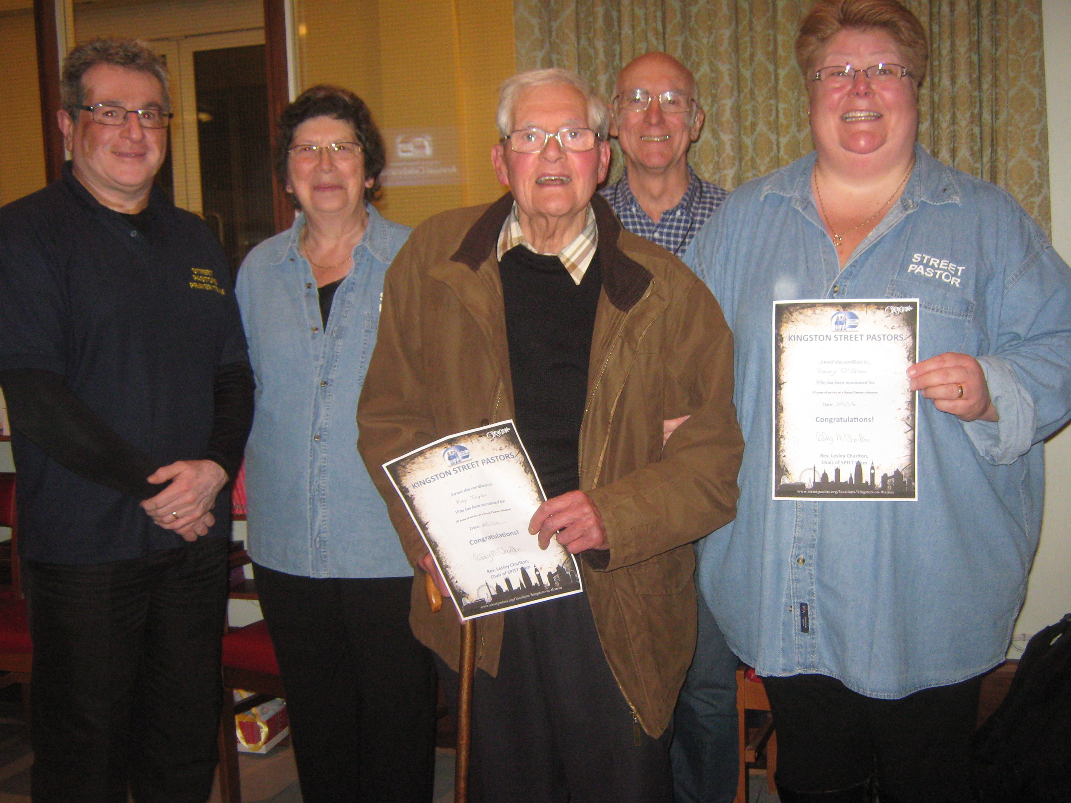

From left to right: Award winners: Shervin Nejand, Katie Beckett, Ray Taylor, Meryn Broomhead and Tracey O’Shea. (out of picture Teresa James)

On Sunday we celebrated our tenth anniversary and awards were given to several Street and Prayer Pastors who have been volunteering for ten years. Another three volunteers, Eddie Kear, Fariydoon Beghou and Alison Holt were unable to accept their awards in person. Awards for Outstanding Service to Street Pastors were also announced for Street Pastor Luke Randall and members of the management committee Nick Ellis and Trevor Quy who are stepping down. Special mention was made of Sue Shaw who served as Acting Co-ordinator for over a year when the post of Coordinator unexpectedly became vacant.

The Mayor and Mayoress of Kingston and James Berry MP also attended the service. Bishop John Hendricks gave the sermon reminding us of the merciful character of God.

THANK GOD for those who have given many years’ service to Street Pastors.

NEW GRADUATES CEREMONY

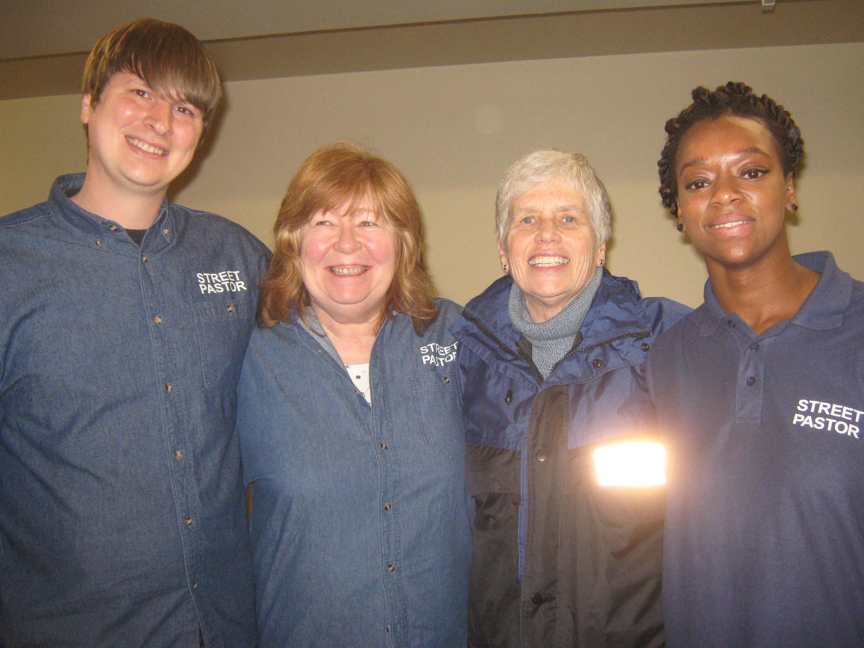
New graduates Charlie Bamford, Anne Skinner, Sarah Stokes and Zainab Turay

New volunteers Charlie Bamford, Anne Skinner, Sarah Stokes and Zainab Turay received their Graduation Certificates at the national Awards Ceremony held at Brixton Hill Methodist Church last Saturday. The awards were presented by Rev. Dr. Graham Kings who spoke about how God got involved in this world by sending Jesus who ‘got his hands dirty’ and he compared this to the way in which Street Pastors serve people on the streets.
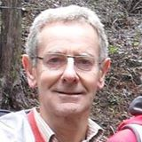
William Allberry also received his certificate for graduating as a Response Pastor. In the event of a major catastrophe William is now trained to deal with the aftermath caused by a major catastrophe.
Recently Response Pastors were called to provide support to those affected by the tragic tram crash in Croydon.

THANK GOD for all our new graduates and pray that they will find their role rewarding.

LAST FRIDAY NIGHTS PATROL

Meryn Broomhead (L); Teresa James ; Tessa McLeod; Isabelle McGrath; Sue Shaw;
Prayer Pastors: Mike Sainsbury; Ray Taylor;

The night was relatively quiet. We provided support to a young medic student who was extremely drunk. He was with seven other young men who helped him home. The team also met a young man (who was sober) scaling down a high wall who turned out to be a professional Parkour athlete otherwise known as a freerunner.
Sue Shaw, Deputy Co-ordinator, Street Pastors Kingston

