Prayer Newsletter 532 Week ending 17th December 2016

Friday’s team - led by Luke Randall with Katie Beckett, Tessa McLeod, Sue Shaw (part); Charlie Bamford; Prayer Pastors: Eddie Kear and Mike Sainsbury. Observer: Kia
Saturday’s team - led by Mark Curzon and Meryn Broomhead with Teresa James, Katie Cooper, Janet McRae, Alan Dean;
FILMING FOR A BBC 3 DOCUMENTARY

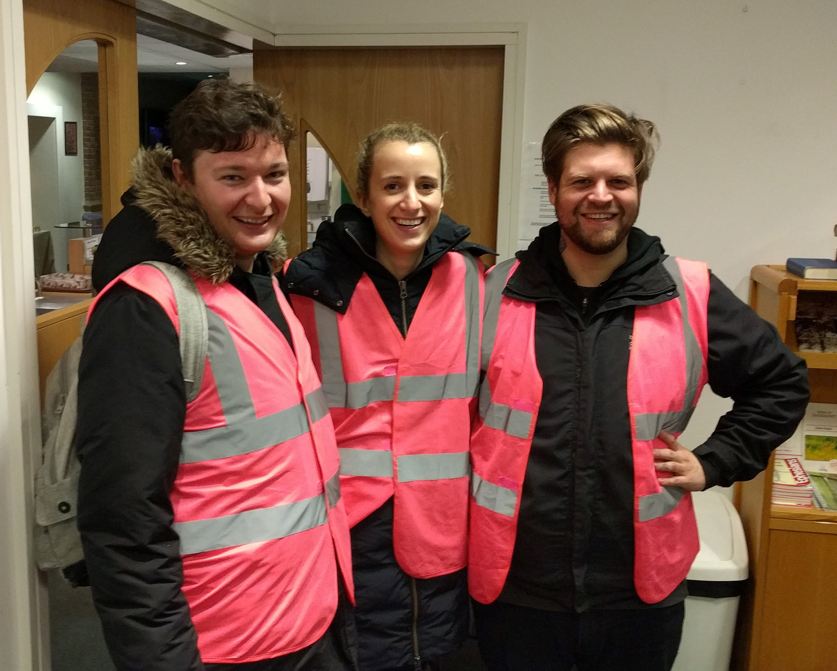
Josh, Grace and Tom from BBC3

On Friday night a film crew from BBC3 joined the team to record a typical Street Pastor night out. The crew led by Director and camerawoman Grace are producing a documentary about the misuse and use of alcohol as part of a series of programmes about drug abuse.
With permission they interviewed and filmed several clubbers and spoke at length to the Street Pastors on duty.
BBC3 is a youth dedicated TV channel available online only. It is subscription free and people should be able to view the finished piece early next year. We will announce the final details when we have them.

THANK GOD
The BBC3 film crew were very positive and sensitive about our work.

PRAY FOR THREE WOMEN

On Friday night the team encountered different women who disclosed different issues:-
Em – Em says she is a lapsed Catholic and needs to right herself with God as she has three children from three different fathers. She left each one for good reasons, they were unfaithful to her. Evidently she feels guilty about her situation as her mother had told her to give one of them who had been unfaithful another chance and she had said no as she was happy about it and her children were happy
Pat – met regular rough sleeper outside McDonalds. She is looking quite perky and bright. She has her bags with her as usual. We asked her what she was doing for Christmas and she said she might go to her father who lives in Norwich in Norfolk. She is thinking of going there by coach. We wished her well and hoped she stays safe.
Lot – This young woman was unfortunately assaulted last week in the club by a group of young men who were quite drunk and had picked her up as a joke. When one of them put her down he sexually abused her and she was very, very upset about that but she didn't know which of the young men it was as there were quite a few around her. When she reported it to the bouncers she was asked if she wanted to get the police involved. She said no at the time but now she has had time to think about it she is very upset and annoyed and wants to take it further. She was quite hysterical at one point and really upset.
PRAY FOR
The differing needs of Em, Pat and Lot, for God to touch their lives in some way.
HELL AT CHRISTMAS?

On Saturday night the team had an interesting conversation with a doorman at Subway, about faith:-
We explained that we come from a range of different denominations and, whatever we are, we all acknowledge that God is a God of love and not of hate or other evil intentions.
The doorman suddenly asked, 'What did we think about hell, what is hell, where is it?' He talked about what his wife thought about hell and he really wanted to know if hell is real. It turned out that he is a Pentecostal and he said he was taught that hell was a burning fire and now they don't say that anymore so what do we believe? In the discussion, Mark said there was one God and the core thing is love, compassion, care, understanding and kindness.

PLEASE PRAY FOR
- Fridays team:- William Allberry (L); Carole and Chris Bourne; Peter Watson; Tony and Anne Geater. Prayer Pastor: Ian Boston
- The Alcohol Recovery Centre and Safe Space at Everyday Church
Sue Shaw, Deputy Co-ordinator, Street Pastors Kingston

