Prayer Newsletter 552 12 May 2017

Friday’s team: Luke R (L); Mark C; Sarah S; Mike and Rosemary B; PP: Katie B

SUICIDE RISK
11.10 We had a really busy start to the evening as near the Hippodrome we met two women, K and G. One of them had been sectioned and they were both suicidal. We walked them to the police station. They wanted to be taken back to hospital. They stayed with us for a while and then they walked away. One was threatening to jump and was climbing up Kingston Bridge. We restrained them and called the police who dealt with the situation.

11.10 Sarah: The two women have now gone back to Roehampton Hospital so we prayed for them and the staff who are going to be receiving them. K, is under section and the other is an informal patient. Both were very distressed and had been self-harming so we are praying for them, asking God to be with them.

BUSY SECOND HALF

1.20 Homeless B was saying how he goes to St Peter's Church Norbiton every week and that he believes in God and rates the vicar there. He told us that as he has a drink problem he can't go to the Joel Project which is only for people who have stopped drinking. He accepted prayer at the end of the conversation.

2.40 Mike: Outside Chiccoland we met a young man who had a bad nosebleed so we helped to clean him up. A girl came along in bare feet so we gave her a pair of flip flops.
2.55 Across from Hippodrome we came across three men in their 20s and early 30s and got into a long conversation about Christianity. One of the guys seemed quite interested.

3.35 Sarah: We have helped a pleasant young man, J who is very drunk, into a taxi with a bit of difficulty. He lost his credit card when trying to get some money out and couldn't remember his code. A very helpful guy at the taxi rank got a taxi for him so he is now going home to Egham.

THANK YOU GOD
- That we were able to help two very distressed women and pray that they will receive appropriate support and treatment.

PLEASE REMEMBER
- Alan Dean, Street Pastor and SPK management member, who has been diagnosed with inoperable cancer.
- Friday’s team:- Phil M (L); Tessa M: Brenda R; Scott F; Katie C; PP: Ray T
- Saturday’s team: Teresa J (L); Jonathan R; Chris & Carole B; PP’s: Lorna C & Rose O;
- Scott Fraser and Simon Tanner in training for Ride London, a 100 mile Sponsored Cycle Ride, in aid of Street Pastors Kingston.
DATES FOR YOUR DIARY

Tues 13th June (7.30pm) | Dementia Friends Training Course  KURC
Thursday 13th July  10am - 4pm | National Prayer Pastor Conference  Speakers:- Les Isaacs and Faith Forster  St Mark’s Church, Kennington  All Prayer Pastors welcome
Sunday 30th July | Ride London - Sponsored Cycle ride  SPK riders - Simon Tanner and Scott Fraser

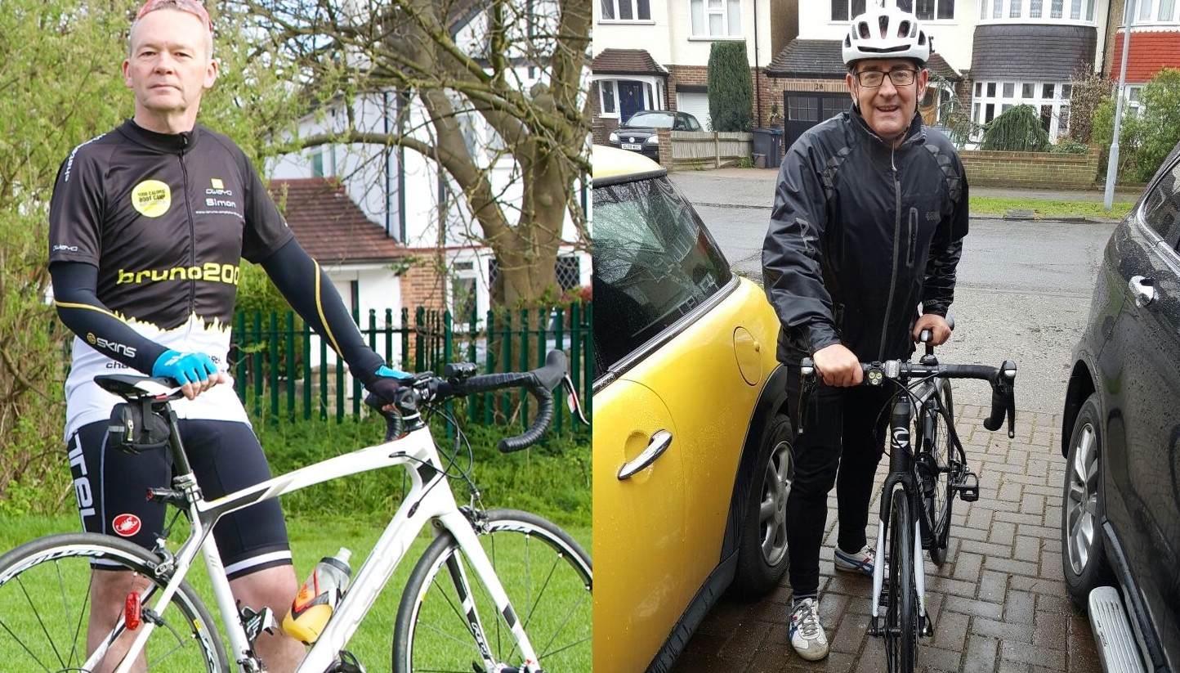
Simon Tanner Scott Fraser
Sue Shaw, Deputy Co-ordinator, Street Pastors Kingston

