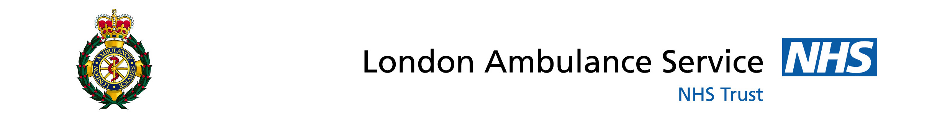

Kingston Alcohol Recovery Centre Trial

Report

By

Kier Maclean, Clinical Team Leader and Centre Manager

January 2015

Contents

Background

Set-up

Resources

Dispatch

Results

Conclusion

Suggestions
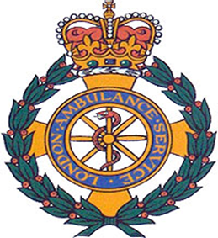

Background

The LAS managed to secure funding from the winter pressure monies to set up a trial in Kingston town centre, to provide a robust framework for the management of intoxicated patients who present to the London Ambulance Service, local police and street volunteers.

Kingston town centre has a large night-time economy with a high volume of intoxicated patients being transported by ambulance to the local Emergency Department at Kingston Hospital.

Set-up

The LAS worked with the Everyday Church in Kingston town centre, who kindly agreed that we could use a room in the church for the Alcohol Recovery Centre (ARC). This, when set up resembled a hospital ward where we could observe all patients at all times.

It was agreed with the medical directorate that the ratio for patients to clinician should be no more than 3:1.

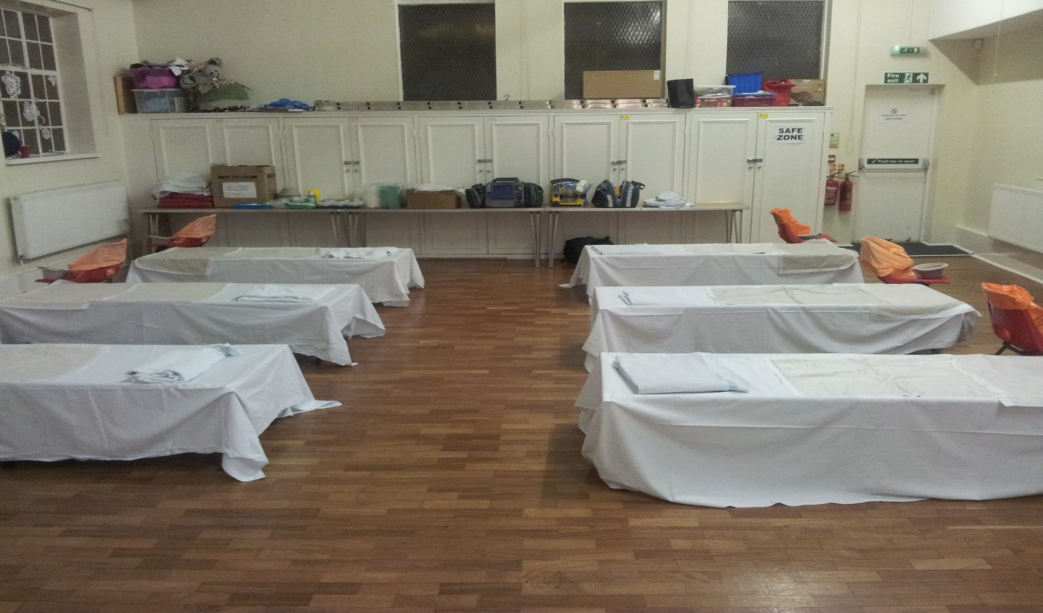

An admission criterion was strictly adhered to. The Centre Manager had overall control of the room and did not provide patient care, which allowed him/her to oversee and co-ordinate the operation.
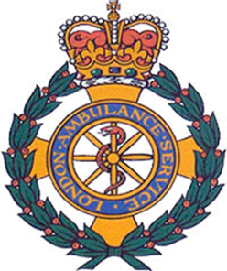
Resources
The LAS provided five members of staff per shift:
- One Centre Manager, working from 19.00 - 07.00;
- Two Clinicians working in the centre from 21.00 - 07.00; and
- Two Clinicians working on the ARV alternative response vehicle (Booze Bus) from 21.00 - 07.00.

The whole project was a multi-agency commitment and we received help from the Metropolitan Police, Kingston First, Kingston Samaritans, Kingston Public Health, Valiant Security, Kingston Street Pastors, and numerous individuals providing support in their own time.

The Everyday Church also opened an area called Safe and Sound, available to vulnerable people at any time of the night. This area was run exclusively by volunteers and was separate from the ARC. However, we did interact and they were a great help in looking after our patients’ friends and relatives.

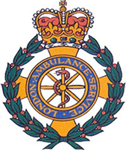

Dispatch
Our emergency operations centre ( EOC ) had been briefed about the project and were up to speed when we contacted them at the start of every shift. The ARV (Booze Bus, Ambulance and crew) was given the call sign ‘S169’ and was not available for auto dispatch. However, it was used on a few occasions when EOC had no resources to cover RED 1 and RED 2 calls.
We were connected to the town centre radio system and also allocated a dedicated mobile telephone number. This number was distributed to the Police and Street Pastors so that they could call us if they were with a patient matching the Kingston ARC admission criteria.
As a result, we received admissions from a variety of sources - all of which would usually have called 999 - as well as admissions from LAS.

The above chart indicates that approximately 45 ambulance calls were prevented as a result of other agencies having direct access to the ARC.

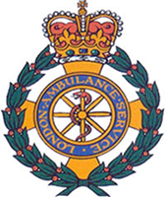

Results
The purpose of the trial was to see how busy Kingston’s town centre would be throughout December and whether we could reduce pressure on Kingston’s Emergency Department and reduce the amount of alcohol related calls to the LAS. The lead-up to Christmas and New Year’s Eve proved to be successful; however, the three shifts around Christmas proved to be very quiet with only four attendances across those shifts.
Total number of patients seen in the Kingston ARC – 64
Of the 64 Patients seen 3 patients were re-admitted to Kingston ED from the ARC.
- Mental Health concerns.
- Fractured Jaw.
- Unstable Obs.

No clinical risks were raised in the Kingston ARC.

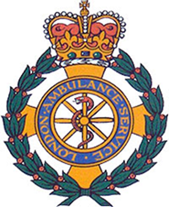

Conclusion

The 3 weekends leading up to Christmas were successful with the ARC treating an average of 7 patients each night. The 3 shifts around Christmas (which included Christmas Eve, Boxing Day and the 27th) proved to be uneventful with an average of 1.5 patients per shift. New Year’s Eve as expected was our busiest night with 18 patients treated.

Overall benefits of the ARC include.
- 64 Patients not admitted to the local ED. Accurate figures are hard to obtain, however every morning post the ARC being open, we consulted with the Senior Sister in the ED, without fail they were very positive about the impact the ARC had on the ED. Only intoxicated patients with other concerns were taken to Kingston ED.

- 45 Ambulance journeys saved.

- Significant time savings for the MET police and street pastors who often spend hours looking after intoxicated patients, whilst waiting for ambulances.

- Reducing crime in the Town centre. For various reasons myself and the MET police feel that having the Alcohol recovery centre can only help make the town centre a safer place. This is for 2 main reasons:

- Having a place where vulnerable people can go and be cared for.
- Freeing the MET up to patrol the town centre.

Suggestions
- To record the average time that our patients stay in the centre onto the existing log. All patient had a full PRF, however a more detailed log would help with statistics.

- To possibly work closer with the Substance misuse team at Kingston Council, to recognise some young people who would benefit from guidance in alcohol misuse, and offer some sort of follow on care.

- As Kingston has an ever expanding University population, we have consulted with the MET who inform us that Wednesday night during term time is extremely busy with a lot of young people ending up intoxicated and in need of assistance. Also fresher’s week which takes place at the end of September would be another good time to open the ARC for a trial, to record numbers that attend.

- With C in mind, consult with the licensing officer and night club managers to find out busy other periods of the year when a pop up ARC would be beneficial to Kingston.

- There is no need to open the centre Christmas Eve and days directly around Christmas as this proved to be an extremely quiet time in the town centre.

- Possibility of running the ARC without S169. This would cut the cost dramatically and as the trail proved over half of patients attending the ARC were not brought in by ambulance.

- Try to encourage Mutual Aid to assist with providing some support.

